**APPOINTMENT SETTER FOR LOCAL BUSINESS**

**ABSTRACT**

In this project, we aim to create a web-based appointment setting system tailored for local businesses. This solution will enable efficient appointment scheduling and management while utilizing modern web development technologies such as HTML, CSS, Bootstrap, PHP, and MySQL.

The primary focus of this system will be on providing a user-friendly interface, ensuring a seamless experience for both businesses and their clients. The front-end design, developed using HTML, CSS, and Bootstrap, will be responsive and intuitive, catering to various devices and screen sizes.

Security will be a top priority, with robust authentication mechanisms for user login and registration. User data will be securely stored and managed in a MySQL database, employing encryption to safeguard sensitive information.

Business owners will have access to a dedicated dashboard where they can efficiently manage appointments, set working hours, and customize their business profiles. Clients, on the other hand, will be able to browse local businesses, view availability, and schedule appointments conveniently.

Real-time updates and notifications will be integrated to facilitate effective communication between businesses and clients, reducing scheduling conflicts and improving engagement. Additionally, calendar integration will be a key feature, allowing businesses to synchronize their appointments with popular calendar applications to avoid double bookings.

Automated reminders and notifications will be sent to both businesses and clients to minimize no-show appointments, enhancing the overall user experience.

To support data-driven decision-making, the system will provide data analytics and reporting tools for business owners. These tools will offer insights into appointment trends, client behavior, and other valuable information to help businesses optimize their services and operations.

The back-end of the system will rely on PHP and MySQL for secure and efficient data management. Data backup and recovery mechanisms will be in place to prevent data loss and ensure the system's reliability.

This web-based appointment setting solution, combining the power of HTML, CSS, Bootstrap, PHP, and MySQL, will serve as a valuable tool for local businesses to streamline their scheduling processes and improve customer satisfaction.

**INTRODUCTION**

In today's fast-paced world, the success of a local business often hinges on the ability to efficiently manage appointments and bookings. To meet this growing need, we present a comprehensive web-based solution that leverages modern web development technologies, including HTML, CSS, Bootstrap, PHP, and MySQL. This innovative appointment setter is designed to empower local businesses with the tools they need to streamline their appointment scheduling processes, enhance customer engagement, and ultimately drive business growth.

Local businesses, such as salons, clinics, fitness centers, and various service providers, face the ongoing challenge of coordinating appointments while providing a convenient and user-friendly experience for their clients. The traditional pen-and-paper or phone-based appointment systems can be time-consuming, error-prone, and often result in missed opportunities and scheduling conflicts.

Our web-based appointment setter offers a solution to these challenges by providing a digital platform that allows businesses to manage their appointments with ease. This system is designed with a focus on user experience and security, ensuring that both business owners and their clients can benefit from a modern and efficient appointment scheduling process.

In the following sections, we will delve into the key features and functionalities of this appointment setter, discussing how HTML, CSS, Bootstrap, PHP, and MySQL collectively drive the system's development. We will explore how these technologies enable us to create a user-friendly interface, implement robust security measures, and offer essential features such as real-time updates, calendar integration, notifications, and data analytics.

By the end of this project, local businesses will have access to a powerful tool that not only simplifies their appointment management but also enhances their ability to engage with clients, reduce no-shows, and make data-informed decisions. This web-based solution is poised to transform the way local businesses operate and improve their overall efficiency and customer satisfaction.

**SYSTEM ANALYSIS**

**EXISTING SYSTEM**

1. **Manual Appointment Scheduling Process:**
   * Traditionally, appointment scheduling involves clients contacting the business via phone calls to book appointments.
   * During the call, clients provide their availability, and staff members manually check schedules to find suitable appointment slots.
   * Staff members then confirm the appointment time with the client over the phone, which can be time-consuming and prone to errors.
   * This manual process is cumbersome, as it requires staff to juggle multiple phone calls, navigate schedules, and find available time slots while ensuring accuracy in appointment bookings.
2. **Challenges of Traditional Approach:**
   * The manual appointment scheduling process is prone to human errors, such as double bookings or scheduling conflicts.
   * It can be time-consuming for both clients and staff, leading to delays in confirming appointments and potential frustration among clients.
   * Keeping track of numerous appointments and storing relevant information manually can be challenging and inefficient, especially as the business grows.
   * Additionally, relying solely on phone calls for appointment scheduling limits accessibility for clients who may prefer alternative methods or have difficulty reaching the business during operating hours.
3. **Difficulty in Appointment Management:**
   * Managing a large volume of appointments manually poses logistical challenges for businesses, particularly those with multiple staff members and service offerings.
   * Staff members must manually update and maintain appointment schedules, which can be prone to oversight and miscommunication.
   * Storing appointment details in physical or digital records may lead to disorganization and difficulty retrieving relevant information when needed.
   * Without a centralized system for appointment management, businesses may struggle to efficiently allocate resources, track client preferences, and analyze appointment trends.
4. **Need for Streamlined Appointment Scheduling Solution:**
   * Recognizing the limitations of traditional appointment scheduling methods, there is a growing need for a streamlined and automated solution.
   * Businesses require a system that simplifies the appointment booking process for clients while providing staff with tools to efficiently manage appointments and maintain accurate records.
   * An ideal solution would offer convenience and flexibility for clients to book appointments online or through alternative channels, reducing reliance on phone calls.
   * Furthermore, the system should incorporate features such as real-time availability updates, automated reminders, and customizable scheduling preferences to enhance the overall appointment experience for clients and staff alike.

**Top of Form**

**Disadvantages**

1. **Inefficiency and Time-Consumption:**
   * Traditional appointment scheduling via phone calls can be inefficient and time-consuming for both clients and staff.
   * Clients may need to wait on hold or make multiple attempts to reach the business, leading to frustration and wasted time.
   * Staff members must manually check schedules, find available time slots, and confirm appointments over the phone, which can be labor-intensive and prone to errors.
2. **Limited Accessibility:**
   * Relying solely on phone calls for appointment scheduling may limit accessibility for clients who prefer alternative methods or have difficulty reaching the business during operating hours.
   * Clients may find it challenging to schedule appointments outside of business hours or during peak call times, leading to missed opportunities for bookings.
3. **Potential for Errors and Conflicts:**
   * The manual nature of phone-based appointment scheduling increases the risk of errors, such as double bookings, scheduling conflicts, or inaccuracies in appointment details.
   * Staff members may inadvertently overlook existing appointments or miscommunicate scheduling information, leading to disruptions and dissatisfaction among clients.
4. **Difficulty in Appointment Management:**
   * Managing a large volume of appointments manually can pose logistical challenges for businesses, particularly those with multiple staff members and service offerings.
   * Staff members may struggle to keep track of numerous appointments, leading to disorganization, missed appointments, and difficulty retrieving relevant information when needed.
5. **Lack of Scalability:**
   * As businesses grow and expand, the manual appointment scheduling process may become increasingly unsustainable.
   * Scaling the process to accommodate a larger volume of appointments and clients can be challenging, leading to bottlenecks, inefficiencies, and reduced customer satisfaction.
6. **Limited Data Insights and Analysis:**
   * Traditional appointment scheduling methods may lack the capability to capture and analyze data related to appointment trends, client preferences, and staff availability.
   * Without access to comprehensive data insights, businesses may struggle to optimize their scheduling processes, allocate resources effectively, and identify opportunities for improvement.

Top of Form

**PROPOSED SYSTEM**

The proposed appointment setter will offer the following features:

1. User-Friendly Interface: The web application will have an intuitive and responsive design created with HTML, CSS, and Bootstrap, ensuring a seamless user experience on both desktop and mobile devices.
2. Secure Authentication: Users, including business owners and clients, will have secure login and registration options to access the system. Their data will be stored and managed in a MySQL database with proper encryption.
3. Business Dashboard: Business owners will have access to a dashboard where they can view and manage their appointments, set working hours, and customize their business profile.
4. Appointment Scheduling: Clients will be able to browse the list of local businesses, view their availability, and schedule appointments at their convenience. Real-time updates and notifications will be implemented to ensure smooth communication.
5. Data Analytics: Business owners will have access to data analytics and reporting tools to track appointment trends, client behavior, and other valuable insights to help them optimize their services.
6. Database Management: The system will employ PHP and MySQL to manage user profiles, appointment records, and business information securely. Data backup and recovery mechanisms will be in place to prevent data loss.

**Advantages**

1. **Enhanced User Experience:** The user-friendly interface, coupled with responsive design, ensures that both business owners and clients can easily navigate the system on various devices, leading to a positive user experience and increased engagement.
2. **Security and Privacy:** The secure authentication mechanism and encryption of user data in the MySQL database prioritize the security and privacy of users' sensitive information, instilling trust and confidence in the platform.
3. **Efficient Business Management:** The business dashboard empowers business owners to efficiently manage their appointments, customize their profiles, and set working hours, leading to improved organization and productivity in their operations.
4. **Convenient Appointment Scheduling:** Clients benefit from the convenience of browsing local businesses, checking availability, and scheduling appointments at their preferred times, enhancing customer satisfaction and loyalty.
5. **Informed Decision-Making:** Data analytics and reporting tools provide business owners with valuable insights into appointment trends, client behavior, and business performance, enabling informed decision-making and strategic planning for service optimization and growth.
6. **Reliable Database Management:** Leveraging PHP and MySQL for database management ensures robust data storage, retrieval, and security measures. Additionally, data backup and recovery mechanisms minimize the risk of data loss, ensuring the integrity and availability of critical information.

**DESCRIPTION OF MODULES**

1. **User Authentication Module:**
   * Manages user registration, login, and logout functionalities.
   * Implements secure password storage and retrieval.
   * Differentiates between different user roles such as clients and administrators.
2. **Appointment Scheduling Module:**
   * Enables clients to view the availability of services or appointments.
   * Provides a user-friendly calendar interface for selecting preferred dates and times.
   * Validates and confirms appointments based on availability and business rules.
3. **Service Offering Module:**
   * Displays a catalog of available services, each with a description and duration.
   * Allows administrators to update and manage service offerings dynamically.
   * Links services to available time slots for appointment scheduling.
4. **User Profile Module:**
   * Enables clients to create and manage their profiles with personal information.
   * Allows clients to view their appointment history and upcoming appointments.
   * Provides options for clients to update contact details or preferences.
5. **Admin Dashboard Module:**
   * Provides administrators with a centralized dashboard for managing appointments.
   * Allows administrators to view, edit, or cancel appointments.
   * Offers analytics and reports on appointment trends and client activity.
6. **Feedback and Review Module:**
   * Enables clients to submit feedback and reviews after completing appointments.
   * Displays client testimonials and ratings on the website.
   * Allows administrators to respond to client feedback and resolve issues.
7. **Security Module:**
   * Implements robust security measures to protect user data and system integrity.
   * Manages access control to ensure that users have appropriate permissions.
   * Regularly updates security protocols to address potential vulnerabilities.
8. **Database Management Module:**
   * Manages the storage and retrieval of appointment-related data using MySQL databases.
   * Ensures data integrity, reliability, and security.
   * Implements backup and recovery mechanisms to prevent data loss.

This modular breakdown provides a foundation for the development of a feature-rich appointment setter website, offering a seamless experience for both clients and administrators. The use of HTML, CSS, Bootstrap, PHP, and MySQL ensures a responsive and dynamic web application that can be easily customized and expanded based on specific business requirements.

**SYSTEM SPECIFICATION**

**HARDWARE SPECIFICATION**

|  |  |
| --- | --- |
| System | HP 15s |
| Processor | Ryzen 5 2.1 GHz |
| Storage | 512 GB SSD |
| RAM | 16 GB |
| Monitor | Integrated Monitor |
| Mouse | Integrated Trackpad |
| Keyboard | Integrated Keyboard |

**OPERATING SYSTEM**

|  |  |
| --- | --- |
| Operating System | Windows 11 |
| Front End | PHP Version 8 |
| Back End | MySQL Version 8 |
| Server | XAMPP |

**SOFTWARE SPECIFICATION**

**SOFTWARE DESCRIPTION**

**XAMPP:**

XAMPP is an [open-source](https://en.wikipedia.org/wiki/Free_software) [cross-platform](https://en.wikipedia.org/wiki/Cross-platform) [web server](https://en.wikipedia.org/wiki/Web_server) [solution stack](https://en.wikipedia.org/wiki/Solution_stack) package developed by Apache Friends, consisting mainly of the [Apache HTTP Server](https://en.wikipedia.org/wiki/Apache_HTTP_Server), [Maria DB](https://en.wikipedia.org/wiki/MariaDB) [database](https://en.wikipedia.org/wiki/Database), and [interpreters](https://en.wikipedia.org/wiki/Interpreter_%28computing%29) for scripts written in the [PHP](https://en.wikipedia.org/wiki/PHP) and [Perl](https://en.wikipedia.org/wiki/Perl) [programming languages](https://en.wikipedia.org/wiki/Programming_language). XAMPP stands for Cross-Platform (X), Apache (A), Maria DB (M), PHP (P), and Perl (P). It is a simple, lightweight Apache distribution that makes it extremely easy for developers to create a local web server for testing and deployment purposes.

Everything needed to set up a web server – server application (Apache), database (Maria DB), and scripting language (PHP) – is included in an extractable file. XAMPP is also cross-platform, which means it works equally well on Linux, Mac, and Windows.

XAMPP's designers intended it for use only as a development tool, to allow website designers and programmers to test their work on their computers without any access to the Internet.

**CROSS-PLATFORM**

Cross-platform software is a type of software application that works on multiple operating systems or devices, which are often referred to as platforms. A platform means an operating system such as Windows, Mac OS, Android, or iOS. When a software application works on more than one platform, the user can utilize the software on a wider choice of devices and computers.

**BENEFITS OF CROSS-PLATFORM**

The benefit of a cross-platform software app or program is that you can use the same program whether you’re on a Windows PC or whether you’re logging in from your laptop or smartphone. The Microsoft Office suite of applications, which includes Word, Excel, and PowerPoint, is available on Windows, Mac OS, iOS (iPhone/iPad), and Android. While there are differences based on how the platforms work, you’ll have a similar experience within the application between all of your devices.

Having a similar experience across any platform means there’s a much smaller learning curve if one even exists at all, so you’ll be more productive and be able to use a software product you’re familiar with regardless of the operating system or device you choose. In addition, your files can be moved much more easily between your devices so you can use the software with whatever device you have with you at the time. And there’s a way to keep all of your work in sync across all of your devices, by using the cloud.

**EXAMPLES OF CROSS-PLATFORM**

**Unity 3D**

First, let’s talk about Unity3D. I think the game engine should be preferred by people who want to write mobile games.  
You can develop games on 17 platforms using multiple languages, including Linux. Of course, iOS, Android, and Windows Phone is also the most ideal game engine to develop games.

You can develop your application using C #, JS, and C ++.

Link to: [https://unity3d.com](https://unity3d.com/)

# Xamarin

Xamarin Some time ago, it was purchased by Microsoft and is a perfect fit for developers using C #.

Because it is a C # language, it has a lot of documentation, and because of Microsoft support, Xamarin is the choice for C # developers.

In addition, you can do everything you can do in Objective-C, Swift, and Java with the Xamarin library.

Link to: [https://xamarin.com](https://xamarin.com/)

# React Native

React Native is an open-source JavaScript library developed by the new generation of React — Facebook, which was open to Github in 2013. Native application creation means writing applications only for a specific operating system. React Native helps developers reuse their code over the web and on mobile. Developers will not have to create the same app from scratch for iOS and Android. They will be able to reuse the code in each operating system. The great thing about React Native is that there is little difference between a finished application in Objective-C or Java and an application built using React Native. Android and iOS code development environments are very different. So it takes time to remove the application to two different platforms. However, with React Native, only one developer can write on different mobile operating systems.

**APACHE:**

The Apache HTTP Server, colloquially called Apache is a [free and open-source](https://en.wikipedia.org/wiki/Free_and_open-source) [cross-platform](https://en.wikipedia.org/wiki/Cross-platform) [web server](https://en.wikipedia.org/wiki/Web_server) software, released under the terms of [Apache License](https://en.wikipedia.org/wiki/Apache_License) 2.0. Apache is developed and maintained by an open community of developers under the auspices of the [Apache Software Foundation](https://en.wikipedia.org/wiki/Apache_Software_Foundation).

The vast majority of Apache HTTP Server instances run on a [Linux distribution](https://en.wikipedia.org/wiki/Linux_distribution), but current versions also run on [Microsoft Windows](https://en.wikipedia.org/wiki/Microsoft_Windows), [OpenVMS](https://en.wikipedia.org/wiki/OpenVMS),  and a wide variety of [Unix-like](https://en.wikipedia.org/wiki/Unix-like) systems. Past versions also ran on [NetWare](https://en.wikipedia.org/wiki/NetWare), [OS/2](https://en.wikipedia.org/wiki/OS/2), and other operating systems,  including ports to mainframes.

Originally based on the HTTP server, the development of Apache began in early 1995 after work on the NCSA code stalled. Apache played a key role in the initial growth of the [World Wide Web](https://en.wikipedia.org/wiki/World_Wide_Web), quickly overtaking NCSA HTTP as the dominant [HTTP](https://en.wikipedia.org/wiki/HTTP) server. In 2009, it became the first web server software to serve more than 100 million [websites](https://en.wikipedia.org/wiki/Website). As of January 2021, [Netcraft](https://en.wikipedia.org/wiki/Netcraft) estimated that Apache served 24.63% of the million busiest websites, while [Nginx](https://en.wikipedia.org/wiki/Nginx) served 23.21% and Microsoft is in third place at 6.85% (for some of Netcraft's other stats Nginx is ahead of Apache), while according to W3Techs, Apache is ranked first at 35.0% and Nginx second at 33.0% and Cloudflare Server third at 17.3%.

**LANGUAGE SPECIFICATION**

**PHP**

**INTRODUCTION OF PHP**

PHP started as a small open-source project that evolved as more and more people found out how useful it was. Rasmus Lerdorf unleashed the first version of PHP way back in 1994.

* PHP is a recursive acronym for "PHP: Hypertext Preprocessor".
* PHP is a server-side scripting language that is embedded in HTML. It is used to manage dynamic content, databases, session tracking, and even build entire e-commerce sites.
* It is integrated with several popular databases, including MySQL, PostgreSQL, Oracle, Sybase, Informix, and Microsoft SQL Server.
* PHP is pleasingly zippy in its execution, especially when compiled as an Apache module on the Unix side. The MySQL server, once started, executes even very complex queries with huge result sets in record-setting time.
* PHP supports a large number of major protocols such as POP3, IMAP, and LDAP. PHP4 added support for Java and distributed object architectures (COM and CORBA), making n-tier development a possibility for the first time.
* PHP is forgiving: PHP language tries to be as forgiving as possible.
* PHP Syntax is the same as C language.

**What is a PHP File?**

* PHP files can contain text, HTML, CSS, JavaScript, and PHP code.
* PHP code is executed on the server, and the result is returned to the browser as plain HTML.
* PHP files have the extension ".php".

**What Can PHP Do?**

* PHP can generate dynamic page content and it can create, open, read, write, delete, and close files on the server and it can collect form data.
* PHP can send and receive cookies it can add, delete, and modify data in your database and it can be used to control user-access and encrypt data.

**Why PHP?**

* PHP runs on various platforms (Windows, Linux, Unix, Mac OS X, etc.).
* PHP is compatible with almost all servers used today (Apache, IIS, etc.).
* PHP supports a wide range of databases.
* PHP is free.
* PHP is easy to learn and runs efficiently on the server side.

## **What is a Database?**

* A database is a separate application that stores a collection of data. Each database has one or more distinct APIs for creating, accessing, managing, searching, and replicating the data it holds.
* Other kinds of data stores can be used, such as files on the file system or large hash tables in memory but data fetching and writing would not be so fast and easy with those types of systems.
* Nowadays, we use relational database management systems (RDBMS) to store and manage huge volumes of data. This is called a relational database because all the data is stored in different tables and relations are established using primary keys or other keys known as foreign keys.

**MySQL Database**

* MySQL is released under an open-source license. So you have nothing to pay to use it. MySQL is a very powerful program in its own right. It handles a large subset of the functionality of the most expensive and powerful database packages.
* MySQL uses a standard form of the well-known SQL data language. MySQL works on many operating systems and with many languages including PHP, PERL, C, C++, JAVA, etc. MySQL works very quickly and works well even with large data sets.
* MySQL is very friendly to PHP, the most appreciated language for web development. MySQL supports large databases, up to 50 million rows or more in a table.
* The default file size limit for a table is 4GB, but you can increase this (if your operating system can handle it) to a theoretical limit of 8 million terabytes (TB). MySQL is customizable.
* The open-source GPL license allows programmers to modify the MySQL software to fit their specific environments.

**TABLE CREATION**

* Name of the table
* Names of fields
* Definitions for each field
* Field Attribute **NOT NULL** is being used because we do not want this field to be NULL. So if the user tries to create a record with a NULL value, then MySQL will raise an error.
* Field Attribute **AUTO_INCREMENT** tells MySQL to go ahead and add the next available number to the id field.
* Keyword **PRIMARY KEY** is used to define a column as the primary key. You can use multiple columns separated by a comma to define a primary key.

## **ADMINISTRATIVE MYSQL COMMAND**

* **USE DATABASE NAME**: This will be used to select a particular database in the MySQL work area.
* **SHOW DATABASES:** Lists the databases that are accessible by the MySQL DBMS.
* **SHOW TABLES:** Shows the tables in the database once a database has been selected with the use command.
* **SHOW COLUMNS FROM Table name:** Shows the attributes, types of attributes, key information, whether NULL is permitted, defaults, and other information for a table.
* **SHOW INDEX FROM Table name:** Presents the details of all indexes on the table, including the PRIMARY KEY

## **CREATING TABLES USING PHP SCRIPT:**

To create a new table in any existing database you would need to use PHP function **mysqli_query()**.

## **Dropping Tables Using PHP Script:**

Drop an existing table in any database, you would need to use the PHP function **mysqli_query()**.

## **INSERTING DATA USING PHP SCRIPT:**

**CREATE**

Create table statement is used to create a table in MySQL.

**SELECT**

The SELECT statement is used to select data from one or more tables.

**UPDATE**

The UPDATE statement is used to update existing records in a table:

## **DELETE**

The DELETE statement is used to delete records from a table:

**DATABASE DESIGN:**

The data in the system has to be stored and retrieved from the database. Designing the database is part of system design. Data elements and data structures to be stored have been identified at the analysis stage.

They are structured and put together to design the data storage and retrieval system. A database is a collection of interrelated data stored with minimum redundancy to serve many users quickly and efficiently.

The general objective is to make database access easy, quick, inexpensive, and flexible for the user. Relationships are established between the data items and unnecessary data items are removed.

Normalization is done to get an internal consistency of data and to have minimum redundancy and maximum stability. This ensures minimizing data storage required, minimizing chances of data inconsistencies, and optimizing for updates.

**INPUT DESIGN**

The Input design is the main feature of the system. Input design determines the format and validation criteria for data entering the system. Inputs originate with end-users; human factors play a significant role in input design. The input design is designed to control the input, avoid delay, and errors in data, avoid extra steps, to keep the process simple. The design of input focuses on controlling the amount of input required, controlling the errors, avoiding delay, avoiding extra steps, and keeping the process simple. The input is designed in such a way that it provides security and ease of use while retaining privacy.

The following are the general principles, that are considered in designing inputs,

* + - Enter only variable data
    - Do not input data that can be calculated
    - List of values
    - Sequence entry

**OUTPUT DESIGN**

Designing the output is more important than working up with a few layout charts and reports. The outputs are designed based on the issue encountered. It will also take care of who will receive the output, what for it is produced how many details are needed, when it is needed, and by what method.

The outputs designed in this system are easy to use and useful for their jobs. The outputs are simple to read and interpret. The outputs obtained from this system are designed by using a few guidelines, which are given below. The information should be clear and accurate, yet concise and restricted to relevant data. Reports should have titles, data, and descriptive headings for columns of data, numbered pages, and so on.

**SYSTEM TESTING**

System testing is the process of exercising software with the intent of finding and ultimately correcting errors. This fundamental philosophy does not change for web applications, because Web-based systems and applications reside on a network and interoperate with many different operating systems, browsers, hardware platforms, and communication protocols; the search for errors represents a significant challenge for web applications.

The distributed nature of client/server environments, the performance issues associated with transaction processing, the potential presence of several different hardware platforms, the complexities of network communication, the need to serve multiple clients from a centralized database, and the requirements imposed on the server all combine to make testing of client\server architectures.

Testing issues

* Client GUI considerations
* Target environment and platform diversity considerations
* Distributed database considerations
* Distributed processing considerations

**TYPES OF TESTING**

1. Unit Testing

2. Integration Testing

3. Validation Testing

4. User Acceptance Testing

5. System Testing

**Unit Testing**

All modules were tested and individually as soon as they were completed were checked for their correct functionality. Unit testing is carried out by verifying and recovering errors within the boundary of the smallest unit or a module. In this testing step, each module was found to be working satisfactorily per the expected output of the module. In the package development, each module is tested separately after it has been completed and checked with valid data.

**Integration Testing**

The entire project was split into small programs; each of these single programs gives a frame as an output. These programs were tested individually; at last, all these programs were combined by creating another program where all these constructions were used. It causes a lot of problems by not functioning in an integrated manner.

The user interface testing is important since the user has to declare that the arrangements made in the frames are convenient and it is satisfied. When the frames are tested, the end user gives suggestions. Since they were much exposed to do the work manually.

**Validation Testing**

At the culmination of the black box testing software is completely assembled as a package. Interfacing errors have been uncovered and corrected and a final series of tests i.e., validation succeeds when the software functions in a manner that can be reasonably accepted by the customer.

**User Acceptance Testing**

User acceptance testing of the system is the key factor in the success of any system. The system under consideration is tested for user acceptance by constantly keeping in touch with prospective systems at the time of development and making changes whenever required. This is done concerning the input screen design and output screen design.

**System Testing**

This is to verify that all the system elements have been properly integrated and perform allocated functions. Testing is executing a program to test the logic changes made in it to find errors. Tests are also conducted to find discrepancies between the system and its original objective, current specifications, and documents.

**SYSTEM IMPLEMENTATION**

Implementation is the stage in the project where the theoretical design is turned into a working system. The most crucial stage is achieving a successful new system & and giving the user confidence that the new system will work efficiently & and effectively in the implementation stage.

The stage consists of

* + - Testing the developed program with simple data.
    - Detections and correction of errors.
    - Creating whether the system meets user requirements.
    - Testing whether the system.
    - Making necessary changes as desired by the user.
    - Training user personnel.

**Implementation Procedures**

The implementation phase is less creative than the system design. A system project may be dropped at any time before implementation, although it becomes more difficult when it goes to the design phase.

The final report to the implementation phase includes procedural flowcharts, record layouts, report layouts, and a workable plan for implementing the candidate system design into an operational one. Conversion is one aspect of implementation.

**System Maintenance**

Maintenance is the implementation of the review plan. As important as it is, many programmers and analysts are to perform or identify themselves with the maintenance effort. There are psychological, personality, and professional reasons for this. Analysts and programmers spend far more time maintaining programs than they do writing them. Maintenance accounts for 50-80 percent of total system development.

Maintenance is expensive. One way to reduce maintenance costs is through maintenance management and software modification audits.

* Maintenance is not as rewarding or exciting as developing systems. It is perceived as requiring neither skill nor experience.
* Users are not fully cognizant of the maintenance problem or its high cost.
* Few tools and techniques are available for maintenance.
* A good test plan is lacking.
* Standards, procedures, and guidelines are poorly defined and enforced.
* Programs are often maintained without care for structure and documentation.
* There are minimal standards for maintenance.
* Programmers expect that they will not be in their current commitment by the time their programs go into the maintenance cycle.

**SYSTEM DESIGN**

System design is "the process of studying a procedure or business to identify its goals, purposes and create systems and procedures that will efficiently achieve them". Another view sees system analysis as a problem-solving technique that breaks down a system into its component pieces for the study of how well those parts work and interact to accomplish their purpose.

The field of system analysis relates closely to requirements analysis or operations research. It is also "an explicit formal inquiry carried out to help a decision maker identify a better course of action and make a better decision than they might otherwise have made."

* **DESIGN NOTATION**

Design notations are used when planning and should be able to communicate the purpose of a program without the need for formal code. Commonly used design notations are:

* DFD
* ERD
* **DFD (DATA FLOW DIAGRAM):**

A data flow diagram (DFD) is a graphical representation of the "flow" of data through an [information system](https://en.wikipedia.org/wiki/Information_system), modeling its process aspects. A DFD is often used as a preliminary step to create an overview of the system without going into great detail, which can later be elaborated. DFDs can also be used for the [visualization](https://en.wikipedia.org/wiki/Data_visualization) of [data processing](https://en.wikipedia.org/wiki/Data_processing) (structured design). A DFD shows what kind of information will be input to and output from the system, how the data will advance through the system, and where the data will be stored. It does not show information about the timing of the process or information about whether processes will operate in sequence or parallel, unlike a [flowchart](https://en.wikipedia.org/wiki/Flowchart) which also shows this information.

Data flow diagrams were popularized in the late 1970s, arising from the book Structured Design, by computing pioneers Ed Yourdon and Larry Constantine. They based it on the “data flow graph” computation models by David Martin and Gerald Estrin. The structured design concept took off in the software engineering field, and the DFD method took off with it. It became more popular in business circles, as it was applied to business analysis than in academic circles.

**DFD SYMBOLS**

The process that transforms data flow

Source or Destination of Data

Data Flow

Data source

**ENTITY RELATIONSHIP DIAGRAM**

The relation upon the system is structured through a conceptual ER-Diagram, which not only specifies the existential entities but also the standard relations through which the system exists and the cardinalities that are necessary for the system state to continue. The Entity Relationship Diagram (ERD) depicts the relationship between the data objects. The ERD is the notation that is used to conduct the data modeling activity The attributes of each data object noted in the ERD can be described resign a data object description.

The set of primary components that are identified by the ERD are

* + Data object
  + Relationships
  + Attributes
  + Various types of indicators

The primary purpose of the ERD is to represent data objects and their relationships.

**ER-DIAGRAM SYMBOL**

Entity

Relationship

Flow

**INPUT DESIGN**

The input design is the link between the information system and the user. It comprises the developing specifications and procedures for data preparation and those steps are necessary to put transaction data into a usable form for processing can be achieved by inspecting the computer to read data from a written or printed document or it can occur by having people keying the data directly into the system. The design of input focuses on controlling the amount of input required, controlling the errors, avoiding delay, avoiding extra steps, and keeping the process simple. The input is designed in such a way that it provides security and ease of use while retaining privacy.

Input Design is the process of converting a user-oriented description of the input into a computer-based system. This design is important to avoid errors in the data input process and show the correct direction to the management for getting correct information from the computerized system. It is achieved by creating user-friendly screens for the data entry to handle large volumes of data.

The goal of designing input is to make data entry easier and to be free from errors. The data entry screen is designed in such a way that all the data manipulations can be performed. It also provides record viewing facilities. When the data is entered it will check for its validity. Data can be entered with the help of screens.

**DATABASE DESIGN**

The database is designed to manage large bodies of information. The management of data involves both the definitions of structures for the storage of information. In addition, the database system must provide for the safety of the information solved, despite system crashes or attempts at unauthorized access. For developing an efficient database users have to fulfill certain conditions such as controlled redundancy.

* Defining the data
* Inputting the data
* Locating the data
* Accessing the data
* Communicating the data

Revising the data

**Objectives of Database Design**

For designing a database design several objectives have to be met as follows:

* Ease of use
* Control of data integrity
* Control of redundancy
* Control of security
* Data independence (logical & physical)
* Data storage protection
* System performance

**OUTPUT DESIGN**

A quality output is one, which meets the requirements of the end user and presents the information. In any system results of processing are communicated to the users and other systems through outputs. In output design it is determined how the information is to be displaced for immediate need and also the hard copy output. It is the most important and direct source of information to the user. Efficient and intelligent output design improves the system’s relationship to help user decision-making.

Output design generally refers to the results and information that are generated by the system for many end-users; output is the main reason for developing the system and the basis on which they evaluate the usefulness of the application.

In this Online Repository System project output is to view customer details, employee lists, order tracking details, and attendance percentage results.

**SYSTEM FLOW DIAGRAM**

**DATA FLOW DIAGRAM**

**LEVEL 0**

User

Admin

Edits pages and approves or rejects appointments and answers queries

Gets appointment status, and query answer

Looks and manages all data

Register, log in, books appointment and ask query

**LEVEL 1**

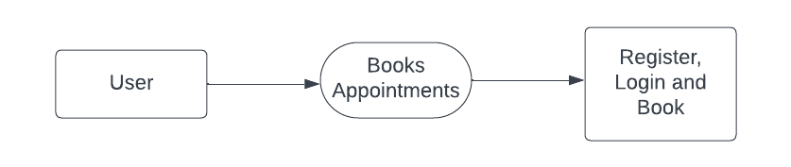

**LEVEL 2**

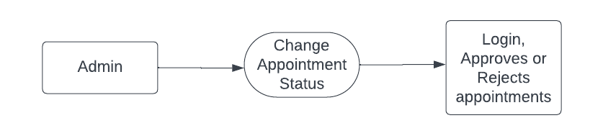

**ER DIAGRAM**

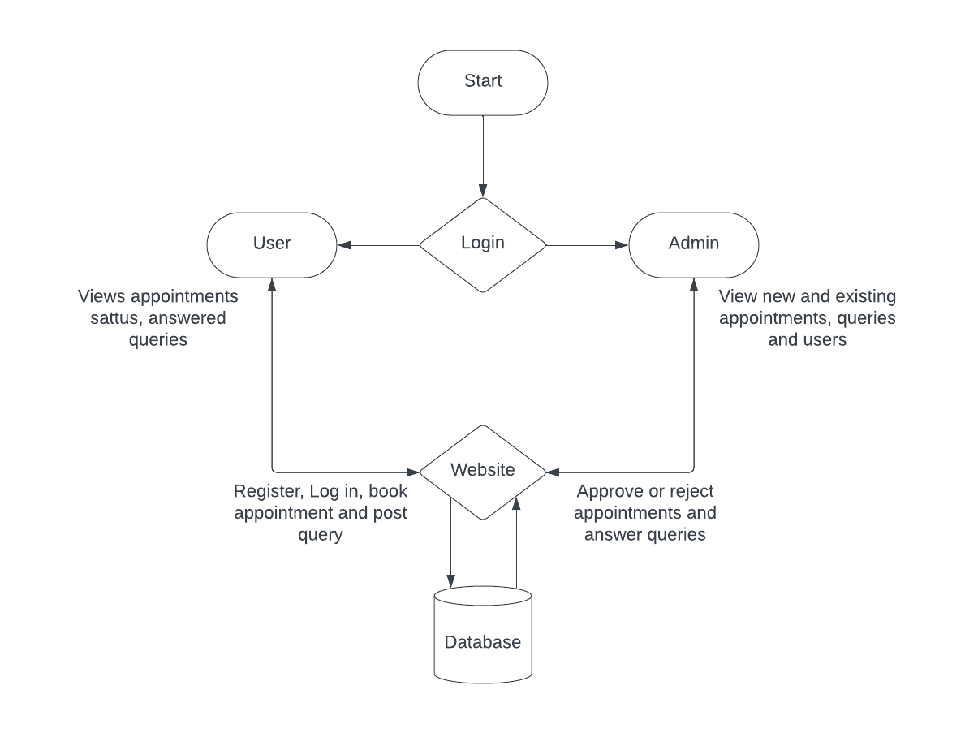

**DATABASE DESIGN**

**Table name: tbladmin**

|  |  |  |  |
| --- | --- | --- | --- |
| **FIELD NAME** | **DATA TYPE** | **LENGTH** | **DESCRIPTION** |
| id | int | 11 | Primary key |
| AdminName | char | 50 | Admin name |
| UserName | char | 51 | Username |
| MobileNumber | bigint | 10 | Mobile |
| Email | varchar | 200 | Email |
| Password | varchar | 200 | Password |
| AdminRegdate | timestamp |  | Registered date |

**Table name: tblbook**

|  |  |  |  |
| --- | --- | --- | --- |
| **FIELD NAME** | **DATA TYPE** | **LENGTH** | **DESCRIPTION** |
| ID | int | 10 | primary key |
| UserID | int(10) | 10 | user id |
| AptNumber | int(10) | 10 | Appointment number |
| AptDate | date |  | Appointment date |
| AptTime | time |  | Appointment time |
| Message | mediumtext |  | Message |
| BookingDate | timestamp |  | Booking date |
| Remark | varchar(250) | 250 | Remarks |
| Status | varchar(250) | 250 | Status |
| RemarkDate | timestamp |  | Remark date |

**Table name: tbluser**

|  |  |  |  |
| --- | --- | --- | --- |
| **FIELD NAME** | **DATA TYPE** | **LENGTH** | **DESCRIPTION** |
| id | varchar | 120 | Unique ID |
| FirstName | varchar | 250 | First name |
| LastName | bigint | 10 | Last name |
| MobileNumber | varchar | 120 | Mobile number |
| Email | varchar | 120 | Email |
| Password | timestamp |  | Password |
| RegDate | varchar | 120 | Registration date |

**CONCLUSION**

In conclusion, the development of a web-based appointment setter for local businesses using HTML, CSS, Bootstrap, PHP, and MySQL represents a significant step forward in modernizing appointment management and enhancing the operational efficiency of local enterprises. This project has successfully addressed the challenges faced by these businesses in coordinating and scheduling appointments while ensuring an optimal user experience for both business owners and clients.

The user-friendly interface, designed with HTML, CSS, and Bootstrap, offers a responsive and intuitive experience that adapts seamlessly to various devices and screen sizes. This accessibility is crucial for ensuring that businesses can cater to a wide range of clientele, regardless of their preferred method of interaction.

The robust security measures incorporated into the system, including secure authentication and encrypted data storage using MySQL, provide peace of mind to both businesses and their clients. Security is a paramount concern in the digital age, and our solution ensures that sensitive information remains confidential and protected.

The various features of this appointment setter, such as real-time updates, calendar integration, and automated notifications, have the potential to transform the appointment management process. Real-time updates and notifications reduce scheduling conflicts and no-shows, thereby improving the overall efficiency and customer satisfaction for local businesses.

Furthermore, the system's data analytics and reporting tools empower business owners to make informed decisions, track appointment trends, and better understand client behavior. This data-driven approach can lead to more efficient business operations and enhanced customer service.

The utilization of PHP and MySQL in the back-end of the system ensures efficient data management and reliable performance. Data backup and recovery mechanisms are in place to safeguard against data loss and ensure the system's resilience.

In conclusion, the appointment setter built with HTML, CSS, Bootstrap, PHP, and MySQL is a valuable tool for local businesses looking to streamline their operations and deliver a superior service to their clients. As technology continues to play a central role in the business world, this solution provides local businesses with the means to thrive and grow while delivering an exceptional experience to their clients. This project marks a significant step forward in the modernization of appointment management for local enterprises.

**SCREENSHOTS**

**Main page**

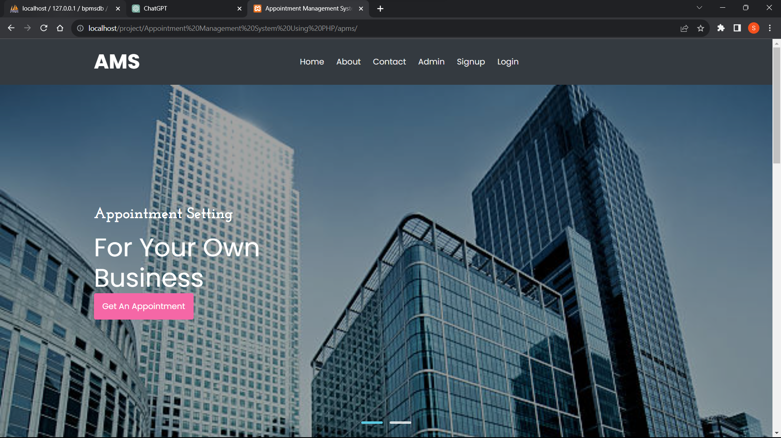

**Book appointment page**

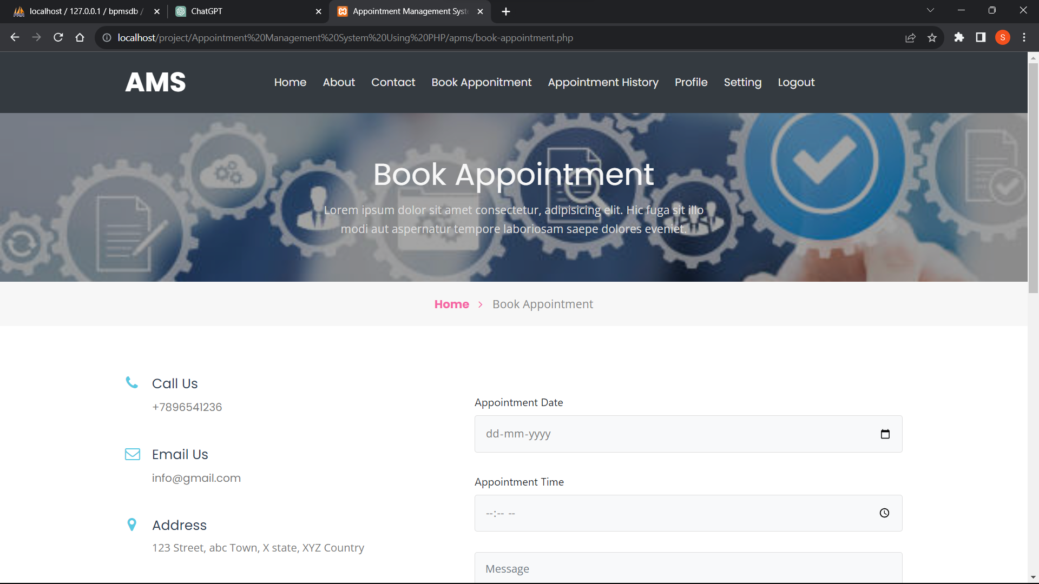

**Admin dashboard**

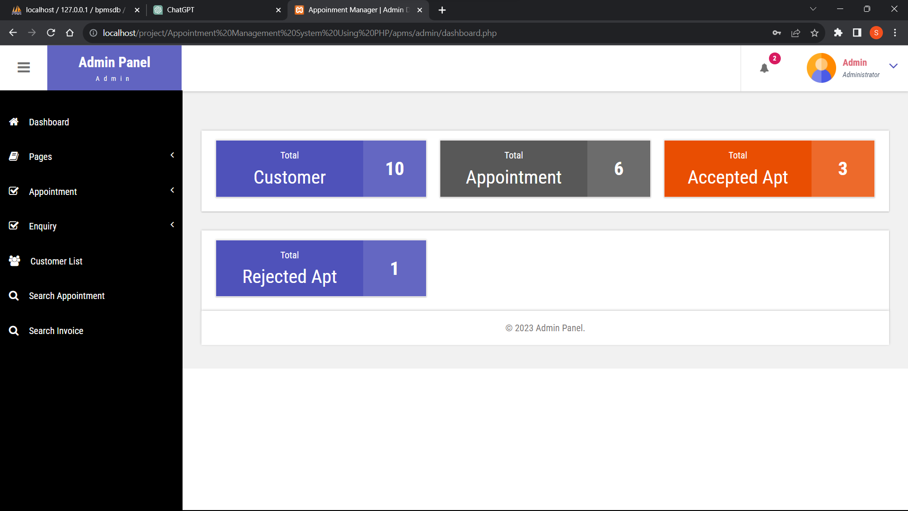

**Appointment management page**

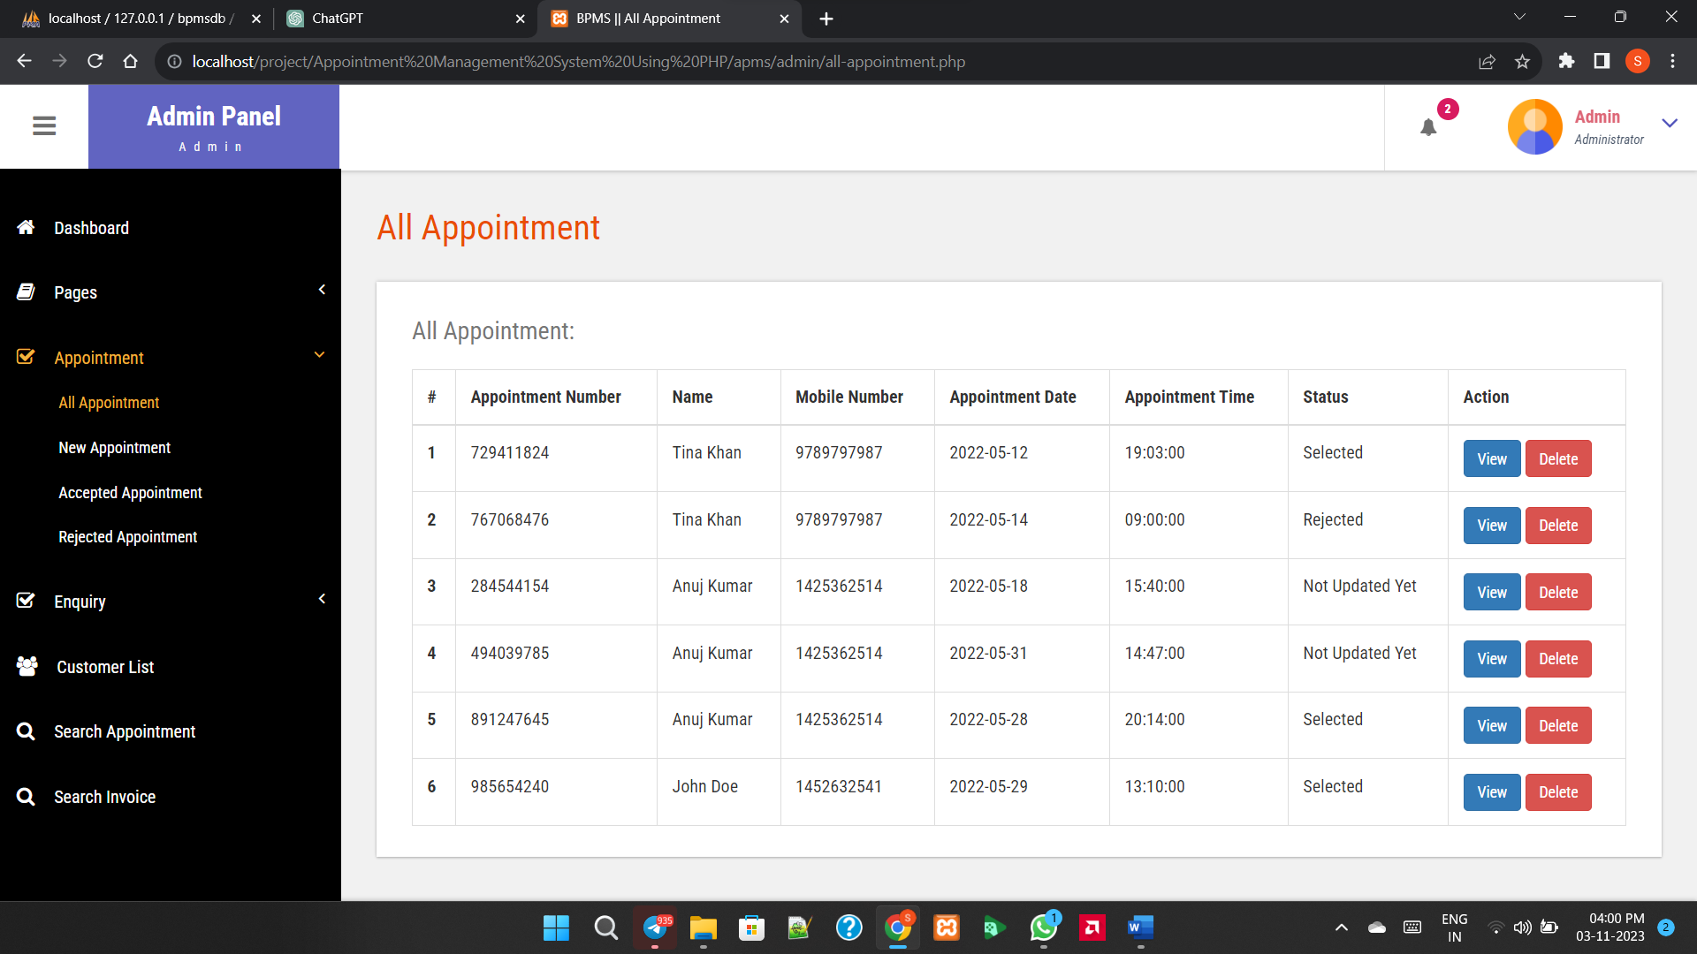

**SAMPLE CODE**

**<?php**

**session_start();**

**error_reporting(0);**

**include('includes/dbconnection.php');**

**?>**

**<!doctype html>**

**<html lang="en">**

**<head>**

**<title>Appointment Management System | Home Page</title>**

**<!-- Template CSS -->**

**<link rel="stylesheet" href="assets/css/style-starter.css">**

**<link href="https://fonts.googleapis.com/css?family=Josefin+Slab:400,700,700i&display=swap" rel="stylesheet">**

**<link href="https://fonts.googleapis.com/css?family=Poppins:400,700&display=swap" rel="stylesheet">**

**<link href="https://fonts.googleapis.com/css?family=Open+Sans&display=swap" rel="stylesheet">**

**</head>**

**<body id="home">**

**<?php include_once('includes/header.php');?>**

**<script src="assets/js/jquery-3.3.1.min.js"></script> <!-- Common jquery plugin -->**

**<!--bootstrap working-->**

**<script src="assets/js/bootstrap.min.js"></script>**

**<!-- //bootstrap working-->**

**<!-- disable body scroll which navbar is in active -->**

**<script>**

**$(function () {**

**$('.navbar-toggler').click(function () {**

**$('body').toggleClass('noscroll');**

**})**

**});**

**</script>**

**<!-- disable body scroll which navbar is in active -->**

**<div class="w3l-hero-headers-9">**

**<div class="css-slider">**

**<input id="slide-1" type="radio" name="slides" checked>**

**<section class="slide slide-one">**

**<div class="container">**

**<div class="banner-text">**

**<h4>Appointment Setting</h4>**

**<h3>For your own<br>**

**Business</h3>**

**<a href="book-appointment.php" class="btn logo-button top-margin">Get An Appointment</a>**

**</div>**

**</div>**

**</section>**

**<input id="slide-2" type="radio" name="slides">**

**<section class="slide slide-two">**

**<div class="container">**

**<div class="banner-text">**

**<h4>Appointment Setting</h4>**

**<h3>For your own<br>**

**Business</h3>**

**<a href="book-appointment.php" class="btn logo-button top-margin">Get An Appointment</a>**

**</div>**

**</div>**

**<!-- <nav>**

**<label for="slide-2" class="prev">&#10094;</label>**

**<label for="slide-1" class="next">&#10095;</label>**

**</nav> -->**

**</section>**

**<header>**

**<label for="slide-1" id="slide-1"></label>**

**<label for="slide-2" id="slide-2"></label>**

**</header>**

**</div>**

**</div>**

**<section class="w3l-call-to-action_9">**

**<div class="call-w3 ">**

**<div class="container">**

**<div class="grids">**

**<div class="grids-content row">**

**<div class="column col-lg-4 col-md-6 color-2 ">**

**<div>**

**<h4 class=" ">Our company offers you the best services</h4>**

**<p class="para ">ABC company offers - Business Services</p>**

**<a href="about.php" class="action-button btn mt-md-4 mt-3">Read more</a>**

**</div>**

**</div>**

**<div class="column col-lg-4 col-md-6 col-sm-6 back-image ">**

**<img src="assets/images/5.jpg" alt="product" class="img-responsive ">**

**</div>**

**<div class="column col-lg-4 col-md-6 col-sm-6 back-image2 ">**

**<img src="assets/images/6.jpg" alt="product" class="img-responsive ">**

**</div>**

**</div>**

**</div>**

**</div>**

**</div>**

**</section>**

**<section class="w3l-teams-15">**

**<div class="team-single-main ">**

**<div class="container">**

**<div class="column2 image-text">**

**<h3 class="team-head ">Come experience the secrets of Our Business</h3>**

**<p class="para text ">**

**Best company that offers you these services and Lorem Ipsum is simply dummy text of the printing and typesetting industry. Lorem Ipsum has been the industry's standard dummy text ever since the 1500s, when an unknown printer took a galley of type and scrambled it to make a type specimen book. It has survived not only five centuries, but also the leap into electronic typesetting, remaining essentially unchanged. It was popularised in the 1960s with the release of Letraset sheets containing Lorem Ipsum passages, and more recently with desktop publishing software like Aldus PageMaker including versions of Lorem Ipsum.</p>**

**<a href="book-appointment.php" class="btn logo-button top-margin mt-4">Get An Appointment</a>**

**</div>**

**</div>**

**</div>**

**</div>**

**</section>**

**<?php include_once('includes/footer.php');?>**

**<!-- move top -->**

**<button onclick="topFunction()" id="movetop" title="Go to top">**

**<span class="fa fa-long-arrow-up"></span>**

**</button>**

**<script>**

**// When the user scrolls down 20px from the top of the document, show the button**

**window.onscroll = function () {**

**scrollFunction()**

**};**

**function scrollFunction() {**

**if (document.body.scrollTop > 20 || document.documentElement.scrollTop > 20) {**

**document.getElementById("movetop").style.display = "block";**

**} else {**

**document.getElementById("movetop").style.display = "none";**

**}**

**}**

**// When the user clicks on the button, scroll to the top of the document**

**function topFunction() {**

**document.body.scrollTop = 0;**

**document.documentElement.scrollTop = 0;**

**}**

**</script>**

**<!-- /move top -->**

**</body>**

**</html>**

**FUTURE SCOPE**

1. **Integration of AI and Machine Learning**: Future developments could involve the integration of artificial intelligence (AI) and machine learning algorithms to enhance appointment scheduling. These technologies could analyze historical data, user preferences, and other factors to optimize scheduling algorithms, predict appointment demand, and personalize scheduling recommendations for users.
2. **Enhanced Mobile App Experience**: With the increasing use of mobile devices, there's a growing demand for mobile-friendly appointment management solutions. Future developments could focus on creating dedicated mobile applications using technologies like React Native or Flutter to provide a seamless and intuitive appointment booking experience on smartphones and tablets.
3. **Integration with Wearable Devices and IoT**: As wearable devices and Internet of Things (IoT) technologies become more prevalent, there's potential to integrate appointment management systems with wearable devices such as smartwatches and fitness trackers. Users could receive appointment reminders, notifications, and updates directly on their wearable devices, improving convenience and accessibility.
4. **Advanced Analytics and Reporting**: Future systems could incorporate advanced analytics and reporting features to provide deeper insights into appointment scheduling patterns, resource utilization, and user behavior. This could enable administrators to make data-driven decisions, identify trends, and optimize scheduling processes for improved efficiency and customer satisfaction.
5. **Virtual Appointment Management**: With the rise of telemedicine and virtual consultations, future appointment management systems could support virtual appointment scheduling and management. Integration with video conferencing platforms and telehealth solutions could enable users to schedule and attend appointments remotely, expanding access to healthcare and other services.
6. **Blockchain for Security and Privacy**: Blockchain technology could be leveraged to enhance security and privacy in appointment management systems. By using distributed ledger technology, systems could ensure secure storage and sharing of appointment-related data while maintaining user privacy and confidentiality.
7. **Voice-Activated Appointment Scheduling**: Integration with voice-activated virtual assistants such as Amazon Alexa or Google Assistant could enable users to schedule appointments using voice commands. This could provide a hands-free and intuitive booking experience, particularly for users with disabilities or those who prefer voice interaction.
8. **Integration with Calendar Platforms**: Future systems could offer seamless integration with popular calendar platforms such as Google Calendar, Outlook, or Apple Calendar. This would allow users to automatically sync their appointments across multiple devices and calendars, reducing the risk of scheduling conflicts and improving organization.
9. **Geolocation-Based Appointment Suggestions**: Leveraging geolocation technology, appointment management systems could offer location-based appointment suggestions and reminders. Users could receive notifications for nearby service providers or businesses offering relevant services, enhancing convenience and accessibility.
10. **Augmented Reality (AR) for Appointment Visualization**: In certain industries such as home improvement or beauty services, AR technology could be utilized to provide users with visualizations of appointment outcomes. For example, users could preview virtual hairstyles or home renovations before scheduling appointments, improving decision-making and satisfaction.

**REFFERENCES**

BIBLIOGRAPHY

Comprehensive Web Development Textbook References

General Web Development:

• MDN Web Docs: (https://developer.mozilla.org/) - The authoritative source from Mozilla, offering in-depth documentation, tutorials, and references for various web technologies.

• W3Schools: (https://www.w3schools.com/) - A well-established website with interactive tutorials, references, and examples for a wide range of web development topics.

• The Odin Project: (https://theodinproject.com/) - A free, full-stack web development curriculum with a strong focus on practical projects.

• FreeCodeCamp: (https://www.freecodecamp.org/) - Another free coding platform with interactive lessons, projects, and a supportive community for web development learning.

Specific Technologies:

• HTML:

o HTML Dog: (https://www.htmldog.com/) - Offers interactive tutorials, challenges, and references for learning HTML.

• CSS:

o CSS-Tricks: (https://css-tricks.com/) - A popular website with articles, tips, tricks, and best practices for mastering CSS.

• JavaScript:

o JavaScript30: (https://javascript30.com/) - Provides 30 JavaScript coding challenges for practicing and improving your JavaScript skills.

o Eloquent JavaScript Website: (https://eloquentjavascript.net/) - Interactive tutorials and resources aligned with the book "Eloquent JavaScript" by Marijn Haverbeke.

• Bootstrap:

o Get Bootstrap: (https://getbootstrap.com/) - The official Bootstrap website with comprehensive documentation, examples, and tutorials for learning and using the framework.

o Start Bootstrap: (https://startbootstrap.com/) - Offers free Bootstrap templates to use as a starting point for your projects.

• PHP:

o PHP.net: (https://www.php.net/manual/en/index.php) - The official PHP website with comprehensive documentation, tutorials, and a reference manual.

o Laracasts: (https://laracasts.com/) - Features video tutorials and screencasts for learning PHP, Laravel (a popular PHP framework), and other web development topics.

• MySQL:

o MySQL Documentation: (https://dev.mysql.com/doc/) - Official documentation from MySQL, providing detailed information on using the database management system.

o SQLBolt: (https://sqlbolt.com/) - An interactive platform where you can practice writing and running SQL queries, the language used with MySQL.

Community Resources:

• Stack Overflow: (https://stackoverflow.com/) - A question-and-answer website for programmers, where you can search for solutions to your coding problems or ask questions related to web development.

• GitHub: (https://github.com/) - A version control system for code hosting and collaboration. GitHub also offers a wealth of open-source web development projects that you can explore and learn from.

Comprehensive Web Development Online References

General Web Development:

• MDN Web Docs: (https://developer.mozilla.org/) - The authoritative source from Mozilla, offering in-depth documentation, tutorials, and references for various web technologies.

• W3Schools: (https://www.w3schools.com/) - A well-established website with interactive tutorials, references, and examples for a wide range of web development topics.

• The Odin Project: (https://theodinproject.com/) - A free, full-stack web development curriculum with a strong focus on practical projects.

• FreeCodeCamp: (https://www.freecodecamp.org/) - Another free coding platform with interactive lessons, projects, and a supportive community for web development learning.

Specific Technologies:

• HTML:

o HTML Dog: (https://www.htmldog.com/) - Offers interactive tutorials, challenges, and references for learning HTML.

• CSS:

o CSS-Tricks: (https://css-tricks.com/) - A popular website with articles, tips, tricks, and best practices for mastering CSS.

• JavaScript:

o JavaScript30: (https://javascript30.com/) - Provides 30 JavaScript coding challenges for practicing and improving your JavaScript skills.

o Eloquent JavaScript Website: (https://eloquentjavascript.net/) - Interactive tutorials and resources aligned with the book "Eloquent JavaScript" by Marijn Haverbeke.

• Bootstrap:

o Get Bootstrap: (https://getbootstrap.com/) - The official Bootstrap website with comprehensive documentation, examples, and tutorials for learning and using the framework.

o Start Bootstrap: (https://startbootstrap.com/) - Offers free Bootstrap templates to use as a starting point for your projects.

• PHP:

o PHP.net: (https://www.php.net/manual/en/index.php) - The official PHP website with comprehensive documentation, tutorials, and a reference manual.

o Laracasts: (https://laracasts.com/) - Features video tutorials and screencasts for learning PHP, Laravel (a popular PHP framework), and other web development topics.

• MySQL:

o MySQL Documentation: (https://dev.mysql.com/doc/) - Official documentation from MySQL, providing detailed information on using the database management system.

o SQLBolt: (https://sqlbolt.com/) - An interactive platform where you can practice writing and running SQL queries, the language used with MySQL.

Community Resources:

• Stack Overflow: (https://stackoverflow.com/) - A question-and-answer website for programmers, where you can search for solutions to your coding problems or ask questions related to web development.

• GitHub: (https://github.com/) - A version control system for code hosting and collaboration. GitHub also offers a wealth of open-source web development projects that you can explore and learn from.